Lab 4: Disk Image and Partitions
What You Need for this lab
  - Install Virtualbox : https://www.virtualbox.org/wiki/Downloads
  - Install Kali 2021.4. : https://old.kali.org/kali-images/kali-2021.4/
    - Notes: Suggest You configure the disk size of Kali VM 80G because the size of each leakage cases image is 30G+
- Disk image : https://www.dropbox.com/s/1fop1ooadb2yshu/Disk_Image_ID-20210327.001

- Verify the integrity of the disk image
- Create Lab Folder
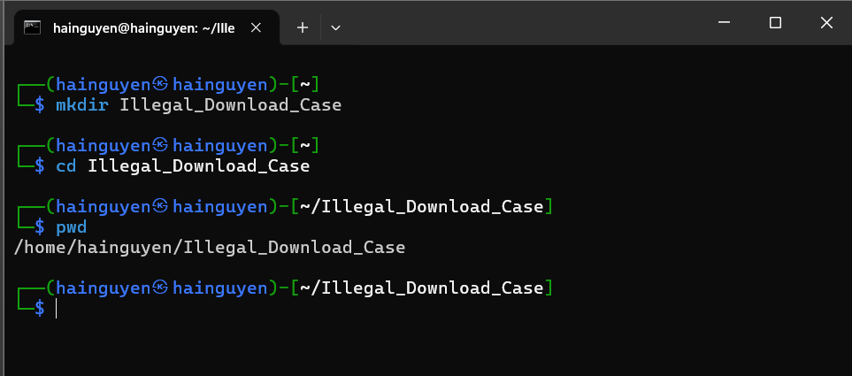
- Download Case Materials
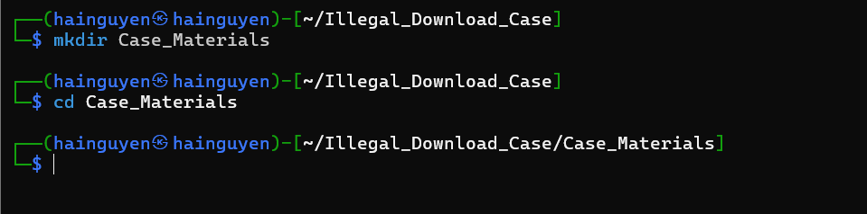

- Use wget to download disk image. ( about 30GB )
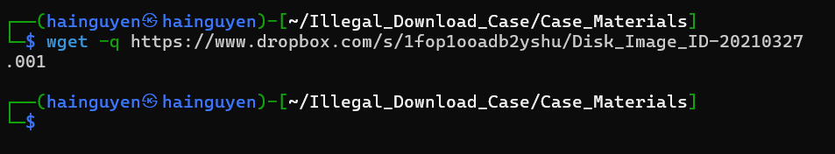
- Record Hash Information
- Open a text file using the text editor Nano:
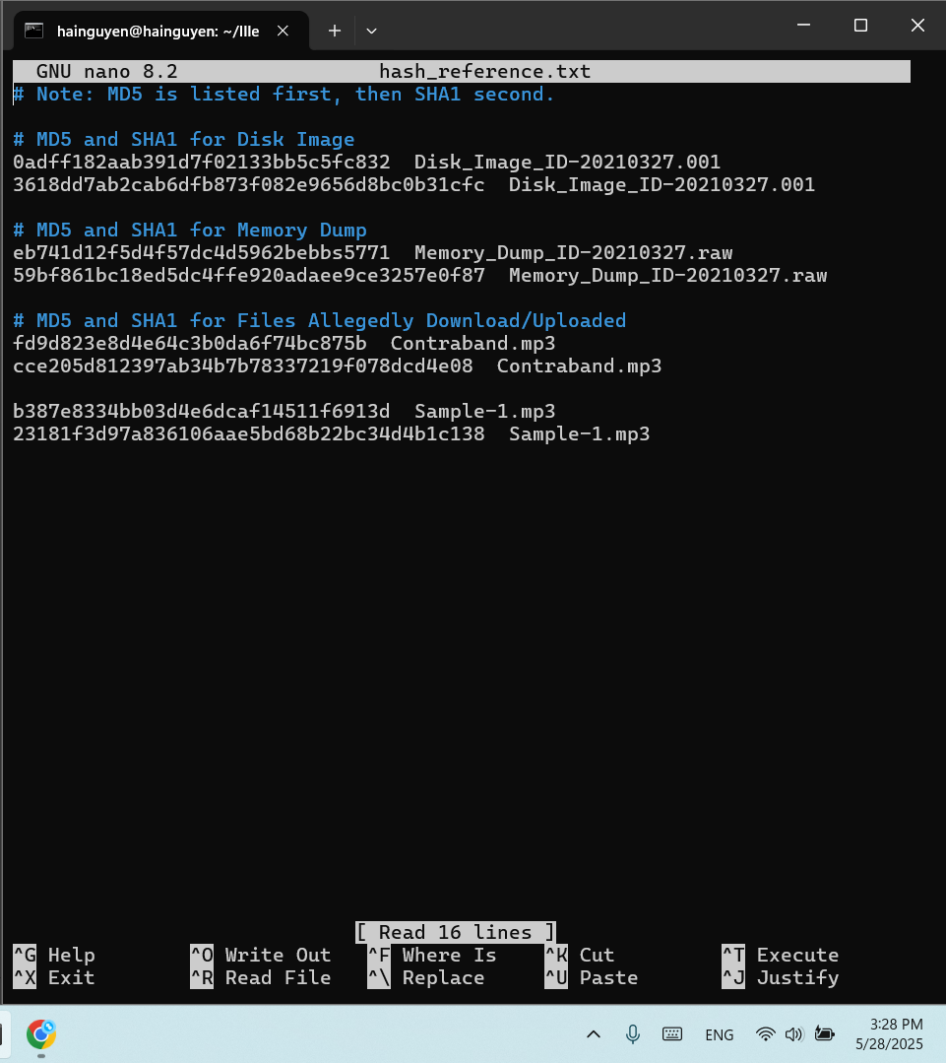
- Install Necessary Software
  - Hashdeep
  - Md5deep
sudo apt install hashdeep
Step 2.
Make sure you are in the lab folder
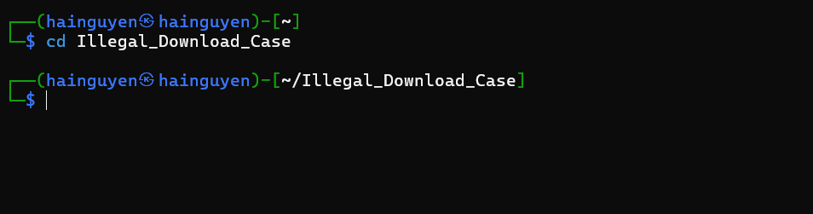
Generate an MD5 and SHA1 hash of the disk image. These tools will compare the MD5 and/or SHA1 hash of the disk image to the MD5 and/or SHA1 hash in the ‘hash_reference.txt’ file.
Commands
  - md5deep <disk image> -bewM <file that contains file names and hash codes>
  - sha1deep <disk image> -bewM <file that contains file names and hash codes>
  - Note: You would replace <disk image> with the file path to the disk image. The same applies to anything else contained in between ‘< >’.
- Use MD5deep to verify the MD5 hash of the disk image.
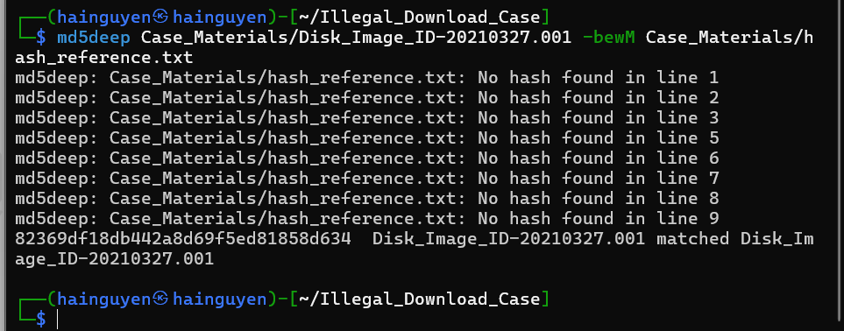

- Use SHA1deep to verify the MD5 hash of the disk image.
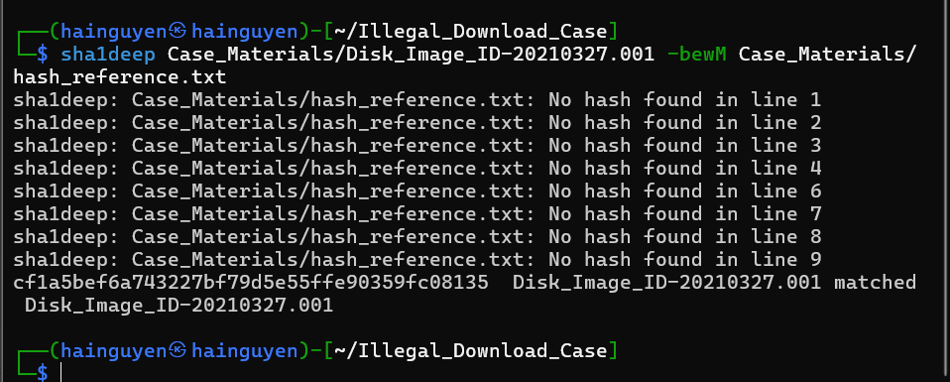
2. Identify the OS of the system as well as its name, accounts, and partitions.
- How to get help for fdisk.
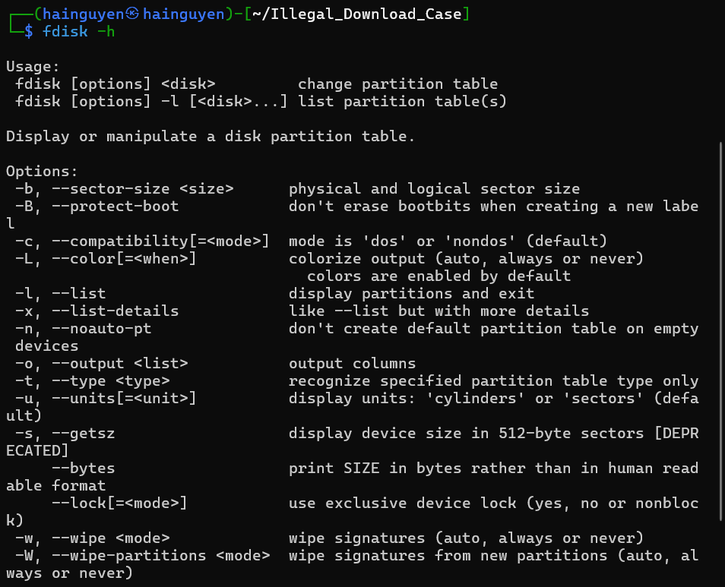

- Use fdisk to get the disk image’s partition table.
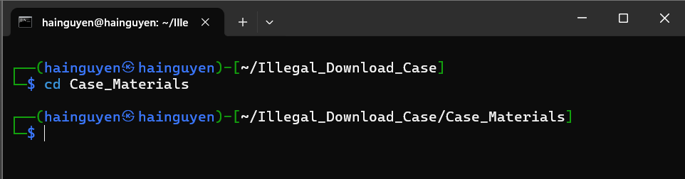
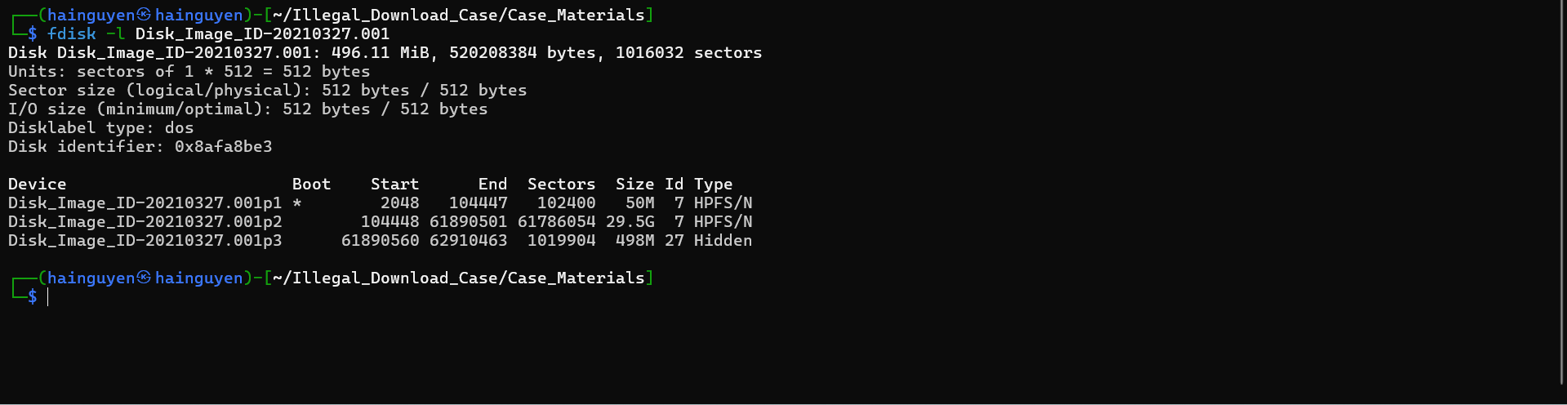
Volume offset #s (in sectors):
- Partition 1 – 2048
- Partition 2 – 104448
- Partition 3 – 61890560
- How to get help for fsstat
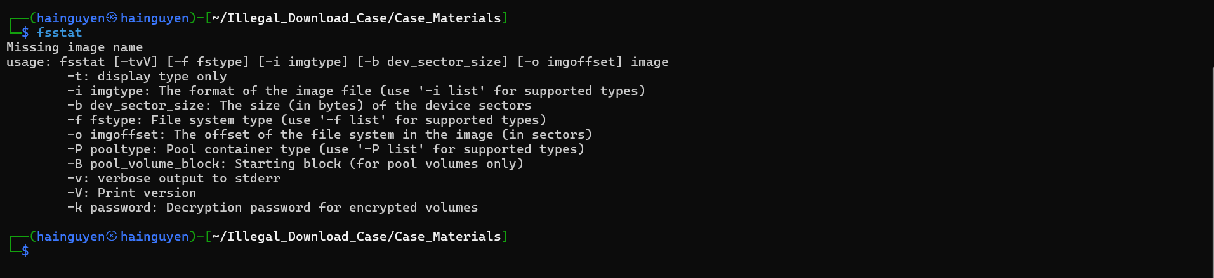
- Use fsstat to get file system details.
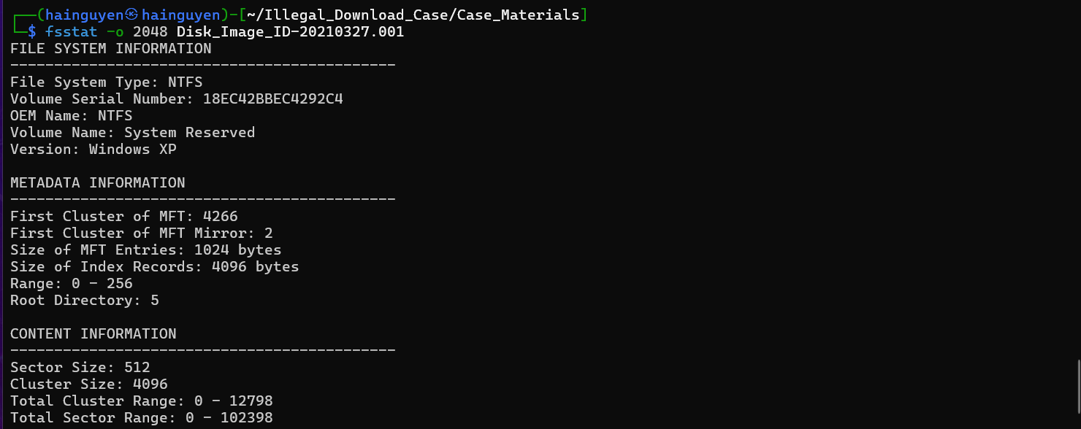
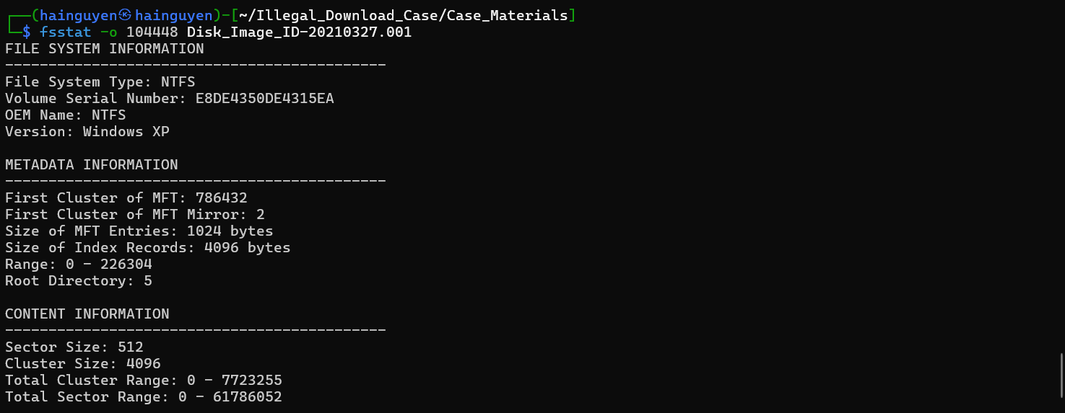
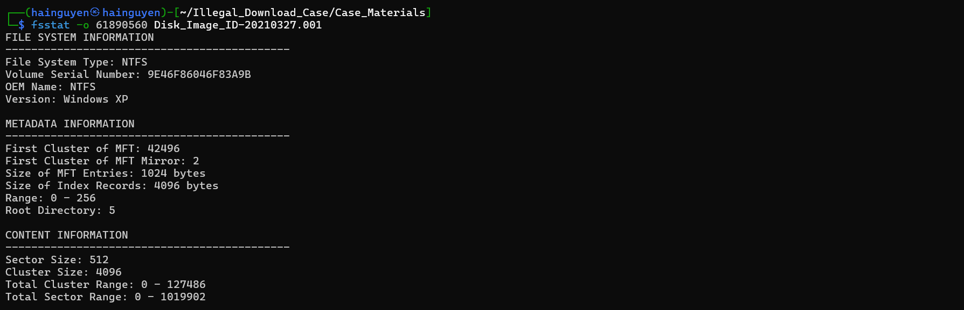
Partition 1
File System: NTFS
Serial Number: 18EC42BBEC4292C4
Partition 2
File System: NTFS
Serial Number: E8DE4350DE4315EA
Partition 3
File System: NTFS
Serial Number: 9E46F86046F83A9B

- Using fdisk and fsstat, we obtained this information:
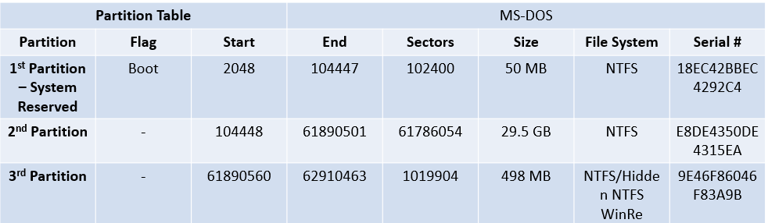
Please explain the parameters in the table ?
Parameter | Explanation
Partition | Indicates the specific partition on the storage device.  - 1st Partition – System Reserved: Often created by Windows during installation and used for boot files.  - 2nd Partition: Typically the main OS or user data partition.  - 3rd Partition: May be recovery or system-specific partition.
Flag | Describes the role of the partition: - Boot: This partition is marked as bootable; the system looks here to start the OS. - “-” (dash): No special flag.
Start | The starting sector number on the disk where the partition begins. Disk sectors are the smallest addressable unit of storage (typically 512 bytes or 4 KB).
End | The ending sector number on the disk where the partition ends.
Sectors | The total number of sectors the partition spans. Calculated as: End - Start + 1.
Size | The total size of the partition, usually calculated by multiplying the number of sectors by the sector size (often 512 bytes). Converted to MB or GB for readability.
File System | The formatting system used to organize files. Examples:  - NTFS: New Technology File System (used by Windows).  - NTFS/Hidden NTFS/WinRe: This suggests a hidden NTFS partition often used for Windows Recovery Environment.
Serial # | A unique identifier for the partition, generated when the partition is created. Used internally by the system.

YOU MUST SUBMIT A FULL-SCREEN IMAGE FOR FULL CREDIT!
Save the document with the filename "YOUR NAME Lab 4.pdf", replacing "YOUR NAME" with your real name.
Email the image to the instructor as an attachment to an e-mail message. Send it to: xxx@fe.edu.vn with a subject line of "Lab 4 From YOUR NAME", replacing "YOUR NAME" with your real name.

